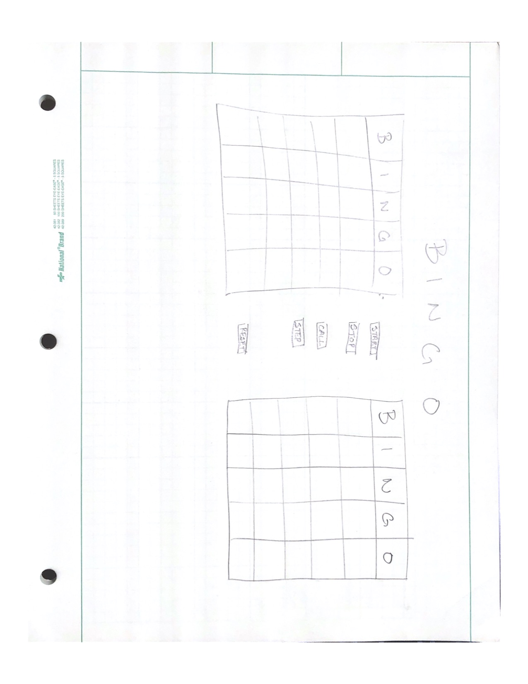Christopher Bell

CSCI 498

Product Design Document

Mockup:

Descriptions:

* Left Bingo Board – Board that autogenerates the numbers in the correct fields, making a complete Bingo board. This board is able to be interacted with and “daubed” by the player.
* Right Bingo Board – Board that autogenerates the numbers in the correct fields, making a complete Bingo board. This board is automatically daubed by a computer algorithm that simulates playing against another person. This would be done by taking in the current letter/number combination and seeing if it matches any space on the board.
* Start Button – Starts the game by flashing letter/number combinations at the top of the screen (the area that says BINGO in the mockup) and cycles through them randomly so that every game is different.
* Stop Button – This stops that auto generation at the top of the screen, letting you essentially pause the game.
* Call Button – When you press this button, it checks to see if you have a legal bingo. If so, it says success, but if not, it says try again and lets you keep going in the game.
* Step Button – If you’d like to take the game more slowly and not automatically, you can choose to use the step button, which progresses the game one letter/number combination at a time.
* Reset Button – After stopping a game, whether by a player winning or when the stop button is pressed, hitting the reset button will give new boards to both players and start the calling process over again.